CHOOSING WHERE TO STUDY AFTER YEAR 11
Leaving School - The Rules
The government has brought in a policy called the RPA (raising the participation age). For most people this policy won't make a big difference. The only change is you now can not leave school age 16 and work full time. You can however, work if training is also provided. You can also continue to study at college or complete an apprenticeship. This sheet is aimed at those considering college.
Different Places you can Study
FE College
6th Form College
School 6th Form
Specialist Provision
Technical College
What Subjects Can You Study and Where?
Depending on the type of college you might be able to study a wide or more limited range of subjects.
What Qualifications Can You Study and Where?
Again depending on the type of college you might be able to study vocational (related to work) subjects such as NVQs or more academic such as A Levels, or a combination of A Levels and BTECs (more course work based qualifications).
Research, Research, Research
Start with looking at college prospectuses (their brochures) and online so you know what is available locally. Talk to friends and family, your careers advisor and teachers.
Visit the College
You can't really get a feel for a place till you have visited and spoken to people. Attend open evenings and taster days for places that you are considering.
Things to Consider
Location - how easy is it to get to? Do the journey.
Class Sizes - do you prefer large or small classes? What do they offer?
Facilities - what's the 6th form area like? Do they have facilities that interest you e.g. Sports
Friends - friends are important but what is right for you is more important!
Teachers/family - listen to their advice but again remember it is your decision
Subject - will the college you like allow you to take the subjects that interest you?
Size of Campus - big/small/spread out/part of the school? Which do you prefer?
Overall Experience - are students given lots of independence?
In Summary
Consider carefully what is important to you
Do your research - Compare and contrast options by writing down positives and negatives
Speak to your school career's advisor
Where Can I study in Brighton and Chichester?
Here is a list of local colleges in Brighton and Chichester areas. See www.elev8careers.org.uk/careers-blog/category/places-to-study for more info,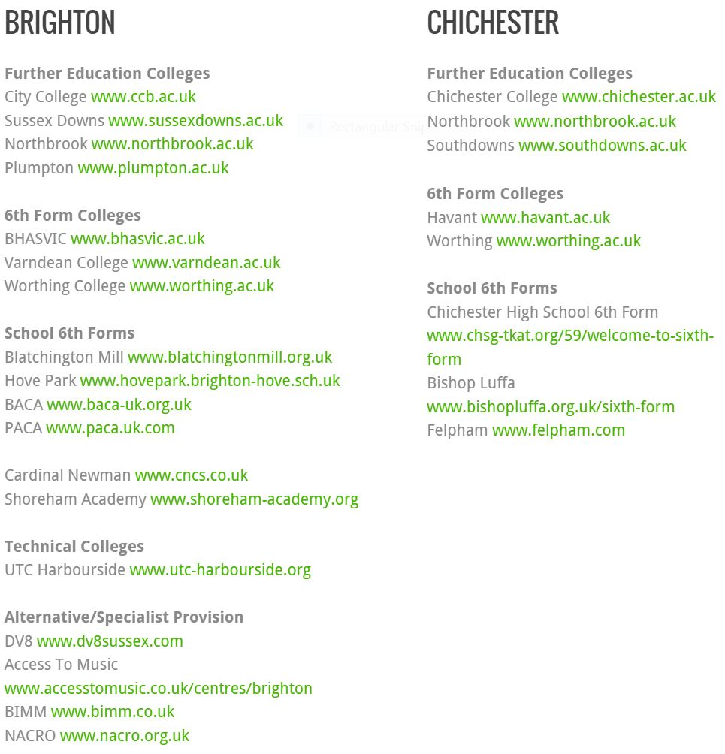
Activity
Spend one hour looking online at the courses available and other things that are important to you at three colleges local to you. Make notes of courses that interest you and anything else that catches your eye (e.g. They have a TV studio and you are interested in media, they have a rugby team and it is your favourite sport etc)

